Close & Settle a Repair Order in ROM – Internal: This topic covers how to close and settle an internal repair order.

Access an Existing Repair Order:

- Press the button.
- Type in the Repair Order # or press the arrow to look it up.
- Press “Enter” or “Tab” to accept the repair order.

Click on Condition 001 to expand the window.

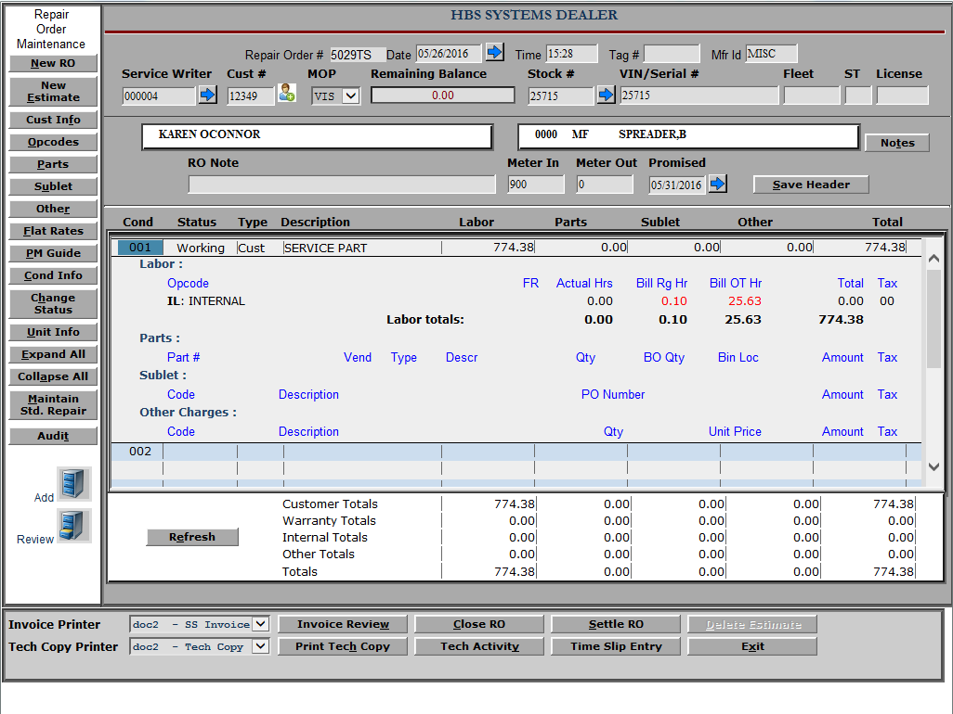

Review Labor: Click on Hours under Bill Rg Hr. A pop-up window of all time slips on this RO/Condition/Opcode appears.

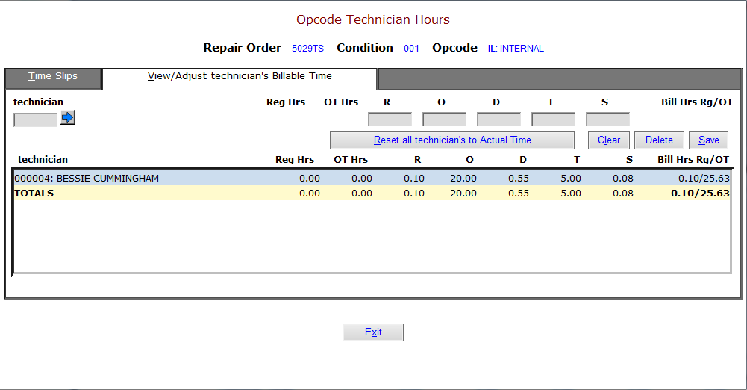

Time Slip Tab: View all times slips by tech.

View/Adjust Technicians Billable Time Tab: Click on a Tech to change billed hours as needed (Reg, O/T, Double, Triple, etc.), and then click Save and Exit.

Invoice Review: Preview Invoice prior to printing.

- Select the “see” printer to display your invoice with totals to the screen.
- Select a printer to get a printout.

Settle: Click on the Settle RO button.

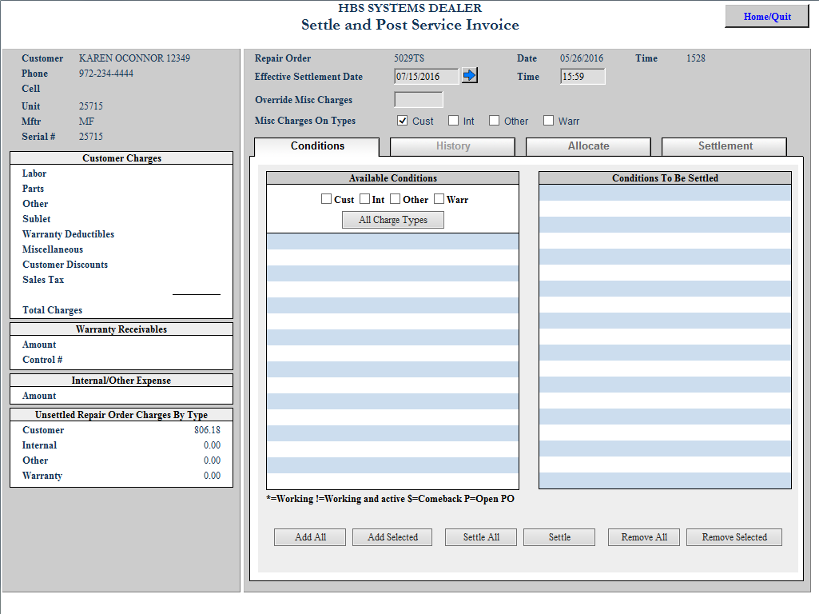

- Click on the All Charge Types button in the center of the screen.
- Click on the Settle All button at the bottom of the screen.
- If there are no special accounting needs, press the Print and Settle button on the bottom of the screen. Check your invoice and press Yes to say it printed ok.
- If you need to adjust the accounting, click on the Allocate Internal Tab.

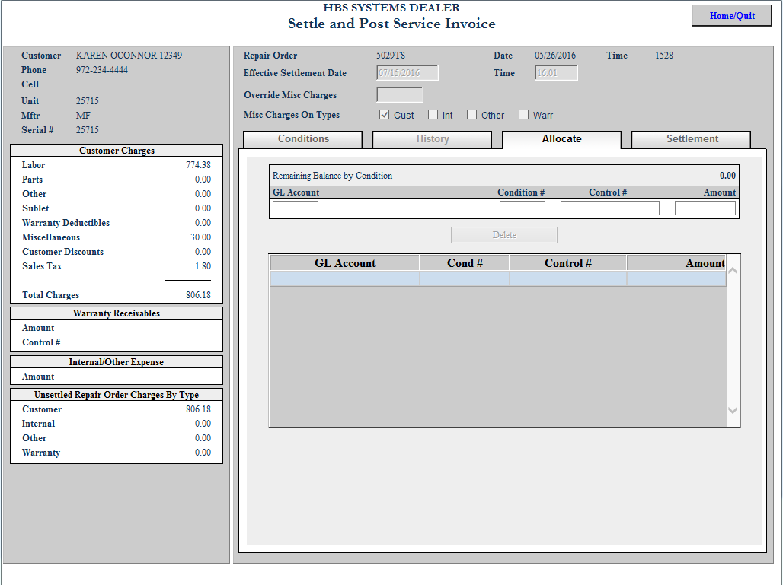

  - Verify or change the G/L account number shown.
    - You may have up to ten G/L accounts referenced on this screen.
    - You may type in the G/L account in the leftmost field or type in a portion of the account number to look it up.
    - Make sure the Unapplied Balance is .00 before continuing.
- Click on the Settlement tab.
- Press the Print and Settle button on the bottom of the screen. Check your invoice and press Yes to say it printed ok.

